**Homework 1: Build your own Docker file, Image, and Container**

**Building the Image:**

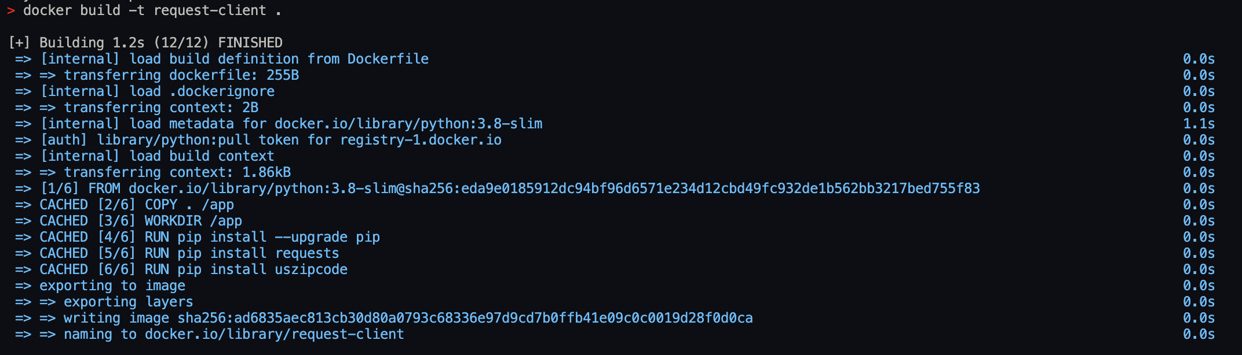

**Running the Container:**



**Browser results by passing city name as parameter:**

**Service 1: Takes City name as variable and prints ZIP CODE**

**Output:**



**Service 2: Takes ZIP Code as variable and outputs weather**

import requests

import json

import sys

"""Takes Zip code as variable and outputs weather"""

def get_weather(zipcode):

api_key = "e116e41a98926eed847b7398fde4f339"

url = "http://api.openweathermap.org/data/2.5/weather?zip={},us&appid={}".format(zipcode, api_key)

response = requests.get(url)

weather_data = json.loads(response.text)

print(f"The weather data for {zipcode} is --->", weather_data)

return weather_data

zipcode = sys.argv[1]

get_weather(zipcode)

**Output**:



**Micro Services working together and testing with Browser Client:**

from http.server import BaseHTTPRequestHandler, HTTPServer

import json

import requests

import http.server

import cgi

from uszipcode import SearchEngine

import requests

import json

search = SearchEngine()

"""Pass the city name and this will be converted to zip code and

the zip code will be used to find the weather

http://localhost:8000/weather/pleasanton"""

def get_weather(city):

result = search.by_city(city)

zipcode = result[0].zipcode

api_key = "e116e41a98926eed847b7398fde4f339"

url = "http://api.openweathermap.org/data/2.5/weather?zip={},us&appid={}".format(zipcode, api_key)

response = requests.get(url)

data = response.json()

data_json = json.dumps(data)

*#print(data_json)*

return data_json

*#get_weather("pleasanton")*

class RequestHandler(BaseHTTPRequestHandler):

def _send_response(self, data_json):

*self*.send_response(200)

*self*.send_header('Content-type', 'application/json')

*self*.send_header('Access-Control-Allow-Origin', '*')

*self*.end_headers()

*self*.wfile.write(bytes(json.dumps(data_json),'utf-8'))

*self*.wfile.write(data_json.encode())

def do_GET(self):

if *self*.path.startswith('/weather'):

city = *self*.path.split('/')[-1]

result = get_weather(city)

*self*._send_response(result)

else:

*self*.send_error(404, "Not Found: %s" % *self*.path)

def run():

server_address = ('', 8000)

httpd = HTTPServer(server_address, RequestHandler)

print('Starting server...')

httpd.serve_forever()

run()

Output:

